Welcome to
The Wheatsheaf
PRIORITY INFORMATION
- Please familiarise yourself with the emergency exits.
The door to the bar is locked overnight
- This building is un-occupied between the hours of 11.00 pm and 8.00 am – any urgent queries please call 0784 5768444 or if that number is unavailable please call 07540 896380
- No smoking inside the building, including rooms
- For your convenience, additional ‘essentials’ are in the bedside table – please only use what you need
- You can be sure of a warm welcome from our staff and locals at the bar and we hope you will join us
- If we can do anything else for you, please just ask - we’d rather help today, than find out at the end of your stay
Welcome
It is a pleasure to welcome you to The Wheatsheaf.

Included in this folder is:
- Fire action notice
- Pub and accommodation details
- Breakfast menu
- Restaurant menu
- Local information

This folder should provide the most essential information for your stay but if there is anything else you require, please do not hesitate to ask a member of staff. If you have any urgent requests during the night, please call 0784 5768444 or if that number is unavailable please call 07540 896380

We welcome your feedback as it allows us to improve our service and facilities. If you have any comments during your stay, please speak to a member of staff so we can take any necessary action promptly.

We hope you have a pleasant and comfortable stay with us, we are grateful for reviews submitted to websites such as TripAdvisor, Google or online booking sites as this helps spread the word about the positive experience we aim to offer.

Regards,

The staff at The Wheatsheaf

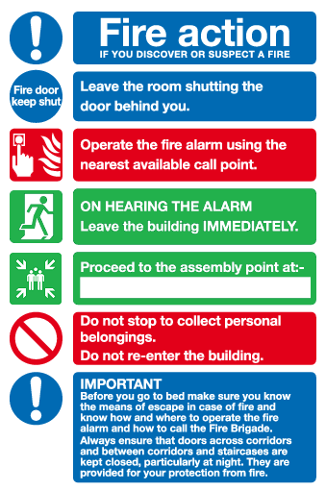

Opening hours
We are open every day from 12.00 pm and you can be sure of a warm welcome from our staff and regulars at the bar.

 | Bar last orders | Restaurant last seating
Monday - Thursday | 11.00 pm | 9:00 pm
Friday  Saturday | 12:00 pm | 9:30 pm
Sunday | 10:30 pm | 8:00 pm
Serving hours may be extended for functions/busier nights

Room access
For security and insurance purposes the door to the pub is locked at night. The Yale-style keys provided are for the alternative entrances; the key with the orange cap is for the car park door, the other key is for the roadside that leads upstairs by room 8.

Free open Wi-Fi
Network names: Wheatsheaf guest and Bedrooms
We have tried to ensure coverage in all areas of the pub. Please bear in mind the difficulty of this within a building of this age.

Smoking
Smoking is not permitted anywhere inside the building.
Instead, please use the outside seating area or other public areas outside.
Guests that do not abide by this will be charged additional cleaning charges and may be asked to leave without a refund.

Complimentary essentials
In addition to the drinks, toiletries and towels, you will find some ‘emergency essentials’ in the bedside table. Please be considerate and only use what you need. In some instances there will only be one set of towels in each room, please don’t hesitate to see a member of staff if you require another set.

Cleaning and laundry
Your room will be serviced each day. Please let us know in the morning if your room requires fresh towels or new bedding, and we will do this during the day. (There may be further charges for this).

An iron, ironing board and hairdryer are available on request.

Departure
We ask that you vacate your room by 10.30 am on the day of your departure. However, we are understanding and flexible so please let us know if you need your room for a little longer and we will try our best to accommodate this.

Parking
Parking is available within our grounds for all customers and guests to use on a first come, first served basis.

Out of hours contact
If you have any urgent enquiries during the night, please call
07845 768444 or if that number is unavailable please call
07540 896380

Breakfast
Breakfast is served in the restaurant from 7.00 am – 9.00 am Monday to Friday and 8.00 am – 10.00 am on weekends and bank holidays.

Our rooms
We hope you enjoy your stay with us and welcome you back again soon.

To check the price and availability of our rooms and to make a booking visit our website www.wheatsheafcrick.com. Alternatively, you can email info@wheatsheafcrick.com or call 01788 823824.

We can also offer business rates and bulk discounts.

Local information

Cash point
There is a free ATM outside the Co-Op.

Village shops
The Co-Op is opposite the front of the pub. Crick Post Office & Stores is 3 minutes walk along Main Road (turn left when leaving the pub).

 | Co-Op | Post Office store | Post Office counter
Monday | 7:00am – 10:00pm | 6:00am – 5:30pm | 9:00am – 1:00pm  2:00pm – 5:30pm
Tuesday
Wednesday |  |  | 9:00am – 1:00pm
Thursday |  |  | 9:00am – 1:00pm  2:00pm – 5:30pm
Friday
Saturday |  |  | 9:00am – 12:30pm
Sunday |  | 6:30am – 12:00pm | Closed

Doctor’s surgery/A&E
Crick Medical Practice (01788 822203)
Cross the road when you leave the pub (onto High Street) and follow for 500 yards.

The nearest A&E is at Northampton General Hospital (22 miles, approx. 25 minutes). Turn right out of the pub, join the M1 southbound, J18, and exit at J15. (NN1 5BD – 01604 634700)

Petrol stations
BP, Hillmorton (on the edge of Rugby) CV22 5EZ (5 miles)
Daventry town centre (8 miles)

